About Us

The Department of Physics offers a unique interdisciplinary educational experience that mirrors the best practices from leading universities around the world. The bachelor of science in physics programme is designed to meet the needs and aspirations of young graduates in adapting to modern era of disruption, by equipping them with strong foundations of scientific knowledge, spirit of inquiry and passion for study and work. The programme provides international exposure and fosters collaboration network with the wider physics community from the east and west.

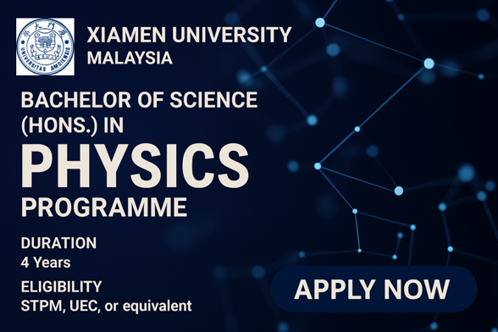
Link: Bachelor of Science in Physics (Honours) | Xiamen University Malaysia

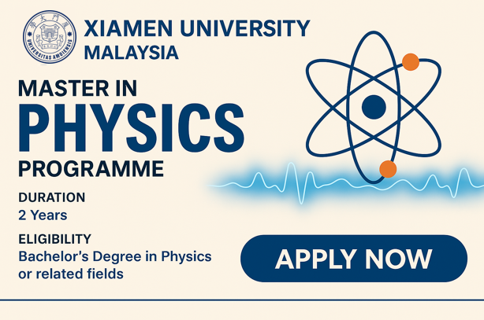
Link: Master and PhD of Science in Physics | Xiamen University Malaysia

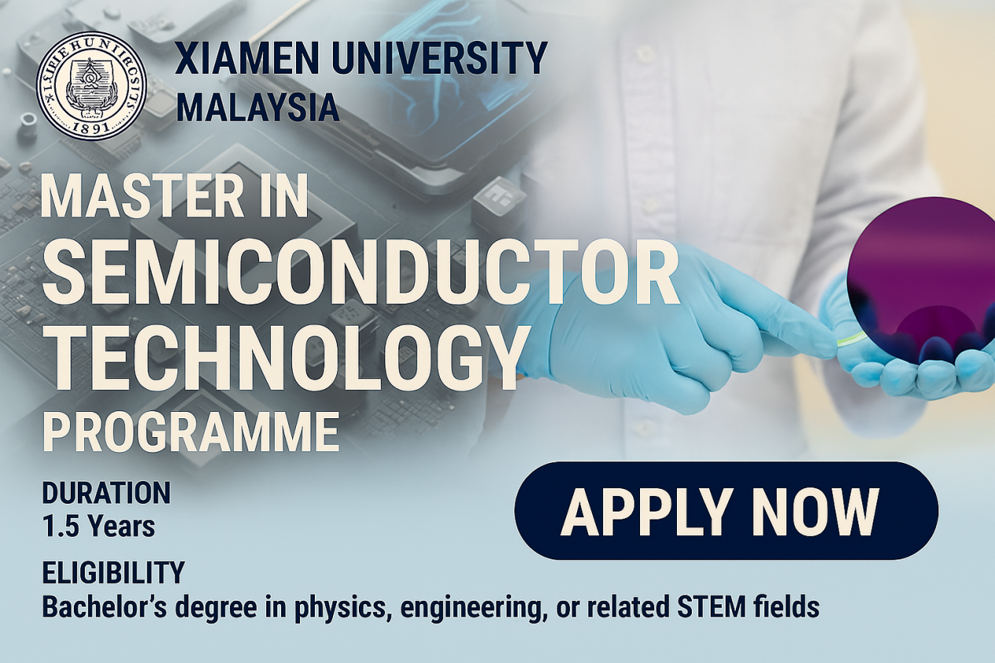
Link: DOP Master in Semiconductor Technology | Xiamen University Malaysia

